Curated by You, for You
Pete Adams, Emmet Allen, Jalen Gill, Christos Markakis, Brian Moran, Maya Rivera, Ben Smith
#Seidenberg School of Computer Science and Information Systems, Pace University
15 Beekman St, New York, NY, USA 10038
pa17459n@pace.edu
ea54209n@pace.edu
jg00681n@pace.edu
cm82580n@pace.edu
bm09585n@pace.edu
mr73526p@pace.edu
bs12253n@pace.edu
November 17th, 2025

Abstract— This report outlines our application developed to address the need to provide listeners, musicians, and music industry professionals with a central place to discover music based on genre and location. We present: Curated by You, for You: a web application that aims to bring users closer to their local music scene, anywhere. Here, we give an overview of the design of CBYFY, focusing on data collection, cleaning, API design, and front-end development.

Keywords— Include at least 5 keywords or phrases
- Introduction
In today’s world, music discovery tools are more abundant than ever. However, tools to find musicians, not just albums or concerts, by location and genre, are strangely scarce. Listeners, promoters, venues, and retail music industry professionals need a simple way to discover artists near them that fall into a particular genre. Yet, commonplace music discovery is largely algorithmic and suggested based on global streaming behavior and ticketed events, not around locale with style in mind. Music Information Retrieval notes that, as recommendation methods and search functionality have matured through apps like Spotify, Apple Music, and YouTube, user needs like location-based searching are still underserved overall [1, 6].

If you take a look at the world's most popular music streaming services with this in mind, you can start to identify the disconnect. Certain platforms like Songkick and Bandsintown are great location-based services that track events and concerts, but that is all that they do. In effect, a similar platform that serves the user a list of artists by city and country, filtered by genre, is an untapped novelty [2, 3]. Major streaming platforms stand in opposition to this by capitalizing on scale. These platforms prioritize algorithmic playlist generation and user-generated content, rather than appropriate direct querying methods through strict categorization of musicians and genres. In fact, advanced genre filtering has taken a backseat to other revenue-driven optimizations, which underscores a gap for targeted discovery at large in this industry [4].

What’s lacking is a platform distant from the idea of maximizing ticket sales and overall streams as its optimization strategy. Rather, a platform that does not exist purely to generate revenue through selling music to the user. Curated by You, for You aims to target that gap directly. Using the free, community-maintained MusicBrainz database, CBYFY enables users to search for artists by location and genre with straightforward filtering methods. Musicbrainz gives us rich, structured metadata on artists, releases, and relationships under open licenses, which gives us a strong foundation and an effective path forward to serve location-first genre-filtered results [5]. By using vetted open data, we avoid any potential integrity or legality issues that might come with a paid corpus of data; that way, we can present transparent, replicable, verifiable results.

Curated by You, for You’s goal is simple. In producing this application, we want to help users discover local artists that match a sound they are looking for quickly, without needing to search across platforms to fill in the gaps. Our application focuses on practical tasks, for instance: “Location = ‘New York’, Genre = ‘rock’”, that present the user with clean outputs. In the sections that follow, we outline the system design, technologies used, the data model, and the API endpoints that power these searches, and how we are leveraging MusicBrainz to keep our results diverse and reliable. We will also discuss the limitations of location granularity and present future steps to deepen our coverage and improve our genre normalization strategy across locations.

- Literature Review
Several platforms already exist that touch different components of what CBYFY aims to address, but most are optimized for listening, event listings, and networking, as opposed to a simple query-based search tool. For example, Radio Garden is a web app that displays an interactive 3D globe where users can tune into thousands of live radio stations from around the world by clicking on a city and choosing a radio station [7]. This is a great tool for users to discover music globally and learn about radio stations, but it does not contain the functionality to actually identify the artist, genre, or even the location of that artist in its output.

Localify is the closest anyone has gotten to addressing the problem we are looking to solve with CBYFY. It is a nonprofit student-built project in collaboration between Ithaca and Cornell universities. It recommends local artists and events based on a listener’s Spotify history, linking streaming preferences with musicians that are geographically nearby the listener [8]. However, Localify is designed to create personalized recommendations rather than search criteria responses, like how CBYFY is configured.

Other platforms, like IMP and Vampr, are designed around professional networking and career development for musicians and artists. Take IMP for example, this app provides tools for independent musicians to showcase their work, collaborate, promote events, and connect with other users, but this site functions a bit more like LinkedIn for musicians[9]. Vampr is a networking application with a similar premise to IMP, but Vampr focuses more on connecting musicians with the intention of building a band remotely or in person. Neither of these applications touches what CBYFY aims to do within the scope of this paper, but future improvements could include networking as core functionality.

As much as these platforms share core components with the ideal CBYFY, their primary focuses in global listening, suggested listening based on user data, and creative network highlight the gap that we aim to fill: there are few tools built specifically to query musicians by location and genre, and none of these applications utilize free, open data sources.

- Project Requirements

- Functional Requirements
The functional requirements for the CFYVY web application are as follows:

Artist Search: The application must allow users to search for artists by location (city and/or country) and genre.

Search Results Display: The application must display search results in a list format showing artist names, locations, and images.

Artist Details: Users must be able to view detailed artist information, including biographical summary, image, and associated albums.

Navigation: This application must route between its home page and search page.

API Endpoints: The backend must contain RESTful API endpoints for retrieving artist information. All endpoints must return respective error messages when data is not found

Data Delivery: This application must serve music data from a structured JSON file containing artist, album, image, and track information organized by genre.

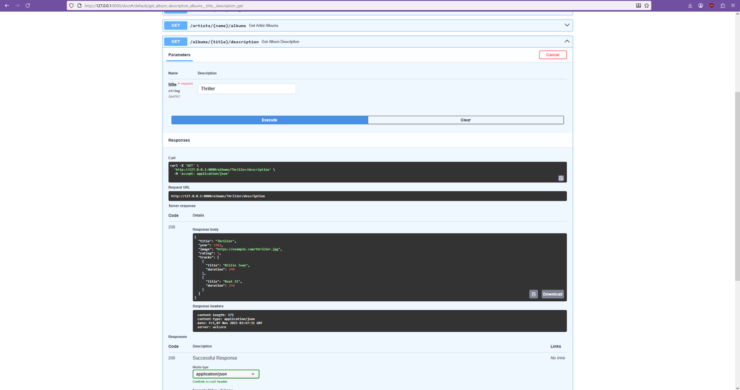
- Non- Functional Requirements
These non-functional requirements must also be met:

Usability: CBYFY should be maintained to allow for simple navigation and a user-friendly interface with consistent styling.
Performance: This application should display search results and artist information accurately and quickly.
Error Handling: CBYFY must handle errors gracefully and effectively, displaying appropriate messages when items are not found or when network requests fail.
Cross-Platform Functionality: This application must run on all modern web browsers

- Methodology

CBYFY was developed to answer a simple, real-world problem that streaming service users face. Initially, we identified the features we wanted to address and moved outward from there. We found our data source, Musicbrainz, cleaned that dataset, and designed our own schema to serve users. We set core search functionality goals and started designing CBYFY using client-server architecture to separate the interface, logic, and data layers. We build our interface, the front-end, with React and Typescript, using Material-UI components. The backend was developed using Python and FastAPI, which handles API requests and processes queries against our JSON data store that contains artist information by genre. We then implemented core features like location-based artist search with genre filtering. This application was tested using pytest for endpoint validation and is deployed on the web.

- API Endpoints

This figure documents the RESTful endpoints that enable communication between our interface and logic layers. Our primary search endpoint /artists accepts genre, country, and city queries. This
Fig. V Example endpoints represented in YAML via Swagger Docs

endpoint returns a list of artists along with their basic information. Endpoint /artists/{name}returns an artist's complete documentation, including their biographical summary, image, and associated albums. All other /artists/{name}/etc.. endpoints return the interior data piecemeal. The /albums/{title}/description endpoint returns album-specific information. All of these endpoints use custom error handling, all of which return HTTP status codes and static error messages when data is not found via query. The API itself is documented with OpenAPI specs, which define parameters, schemas, and data structures for Artist, Album, and track objects.

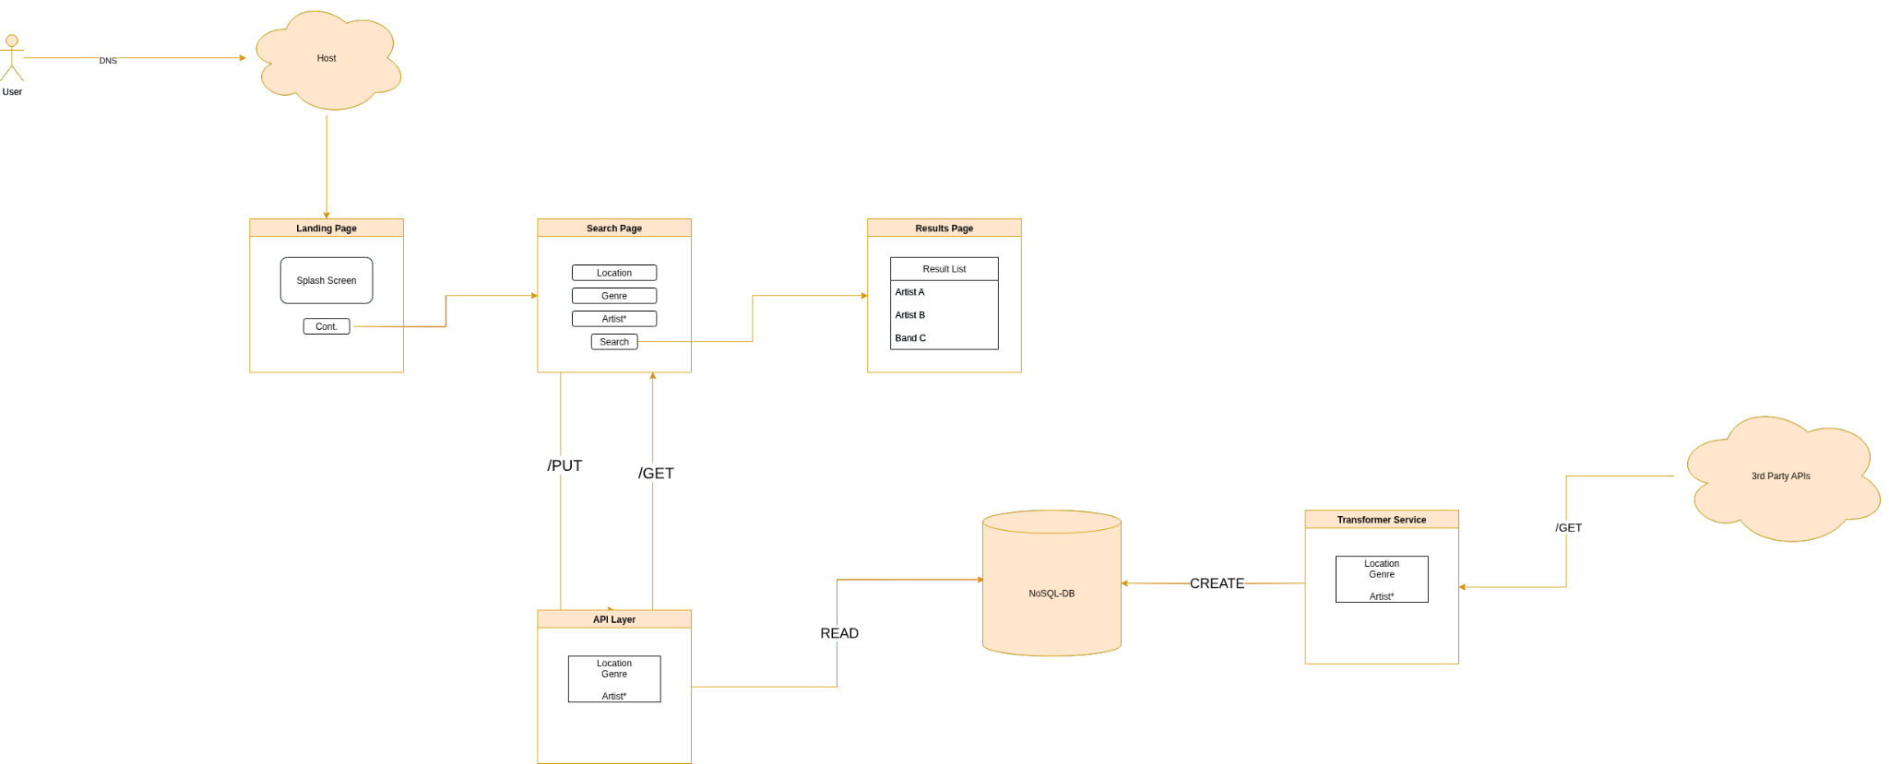
- System Design

Fig. VI Systems Diagram For CBYFY
This figure illustrates the intended data flow and architecture of CBYFY. If you follow the diagram from the top left, where our “user” is, trace the flow from DNS request to our React landing page. When continued, a user must input their request to return artists by location ex: “New York, United States”, and their preferred genre ex: “Rock”. Once selected, our frontend communicates with the backend and sends a GET request for the selected criteria. This GET request is via HTTP directly to our API, with CORS middleware that enables cross-origin communication throughout development. Our backend then processes the request by querying our data source and returns that data to the user on the same page. ++ add 2 figs- Springsteen object, return from host page
- Tests and Results
In order to evaluate our application, we would be testing it with all potential users- musicians, music industry professionals, and listeners. The testing process would focus on functionality, relevant information, and the quality of the user experience. We will be sending our web application to testers via private links and evaluating their experience based on their feedback. Our development path will likely change or be altered slightly by this feedback.

Functionality- Does our application work as intended and provide users with an experience that we stand behind?

Relevant Information- Does our application actually return novel information that the user cannot find in other places?
User Experience- Do users like our interface? Do they like the design? Do they think that navigating our application is intuitive and enjoyable?

- Conclusion
CFYBY demonstrates that a simple query tool can be meaningful in closing the gap created by massive streaming platforms and natural discovery of musicians in an effort to establish community relationships with artists. Since we've utilized free, open-sourced, community-moderated data, we can hold true to our mission of serving the user with nuanced, vetted, human artists. Without bogging our users down with recommendations, we give people a space to discover things on their own, which can create long-lasting positive relationships with the content CBYFY serves.

In the future, we look to continue to build rich features, improve our design and user interface to improve user experience based on testing, and expand our dataset to continue to represent under-documented artists and genres.

In conclusion, CBYFY is an attempt at rethinking music discovery from a technical perspective. This application is an early, but important step towards building functional, useful tools that center around local artists with listeners and professionals at the wheel.

References
- M. Schedl et al., Music Information Retrieval: Recent Developments and Applications. Now Publishers (survey). Now Publishers
- Bandsintown – consumer overview (concert discovery focus). bandsintown.com
- Songkick – consumer overview (concert tracking focus). Songkick
- Spotify community threads indicating changes/limits to advanced/genre search. SpotifyAdvancedSearchRemoval
- MusicBrainz – About & Database (open, community-maintained metadata). MusicBrainz
- P. Knees, Intelligent User Interfaces for Music Discovery (TISMIR, 2020).
- Radio Garden – globe-based radio discovery platform allowing users to explore live radio stations by location. radio.garden
- Localify – nonprofit local-music discovery tool recommending nearby artists based on Spotify listening data. localify.org
- IMP (Independent Music Platform) – portfolio and collaboration platform for independent musicians and industry creatives. imp.social
- Vampr – leading music networking application for musicians to connect, collaborate, and find creative partners. vampr.me
- MusicBrainz – open, community-maintained database of structured music metadata supporting artist and release lookup. musicbrainz.org

